**CIDR**

Pembagian subnet di CIDR dimulai dari yag terjauh dari cloud agar mempermudah routing sehingga didapatkan subnet sebagai berikut

**Class A**

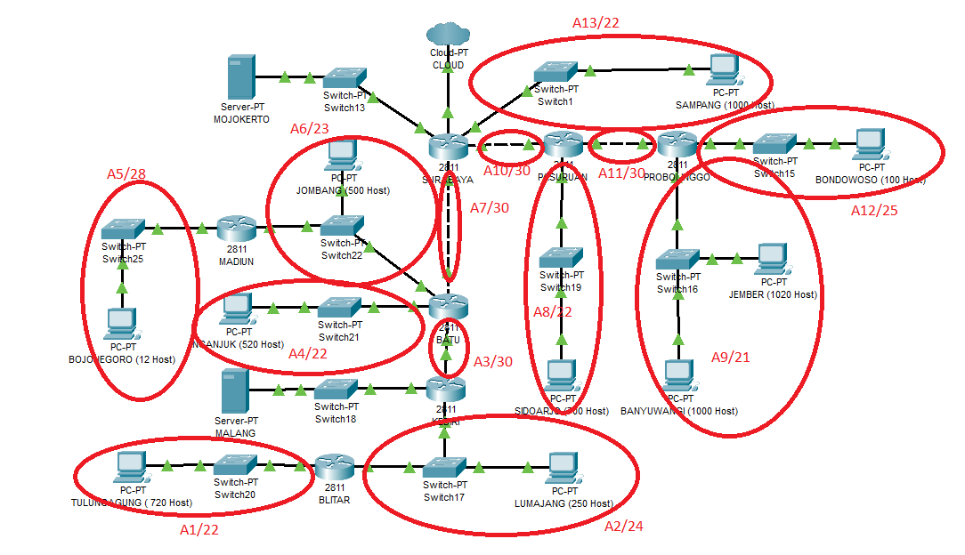

**Class B**

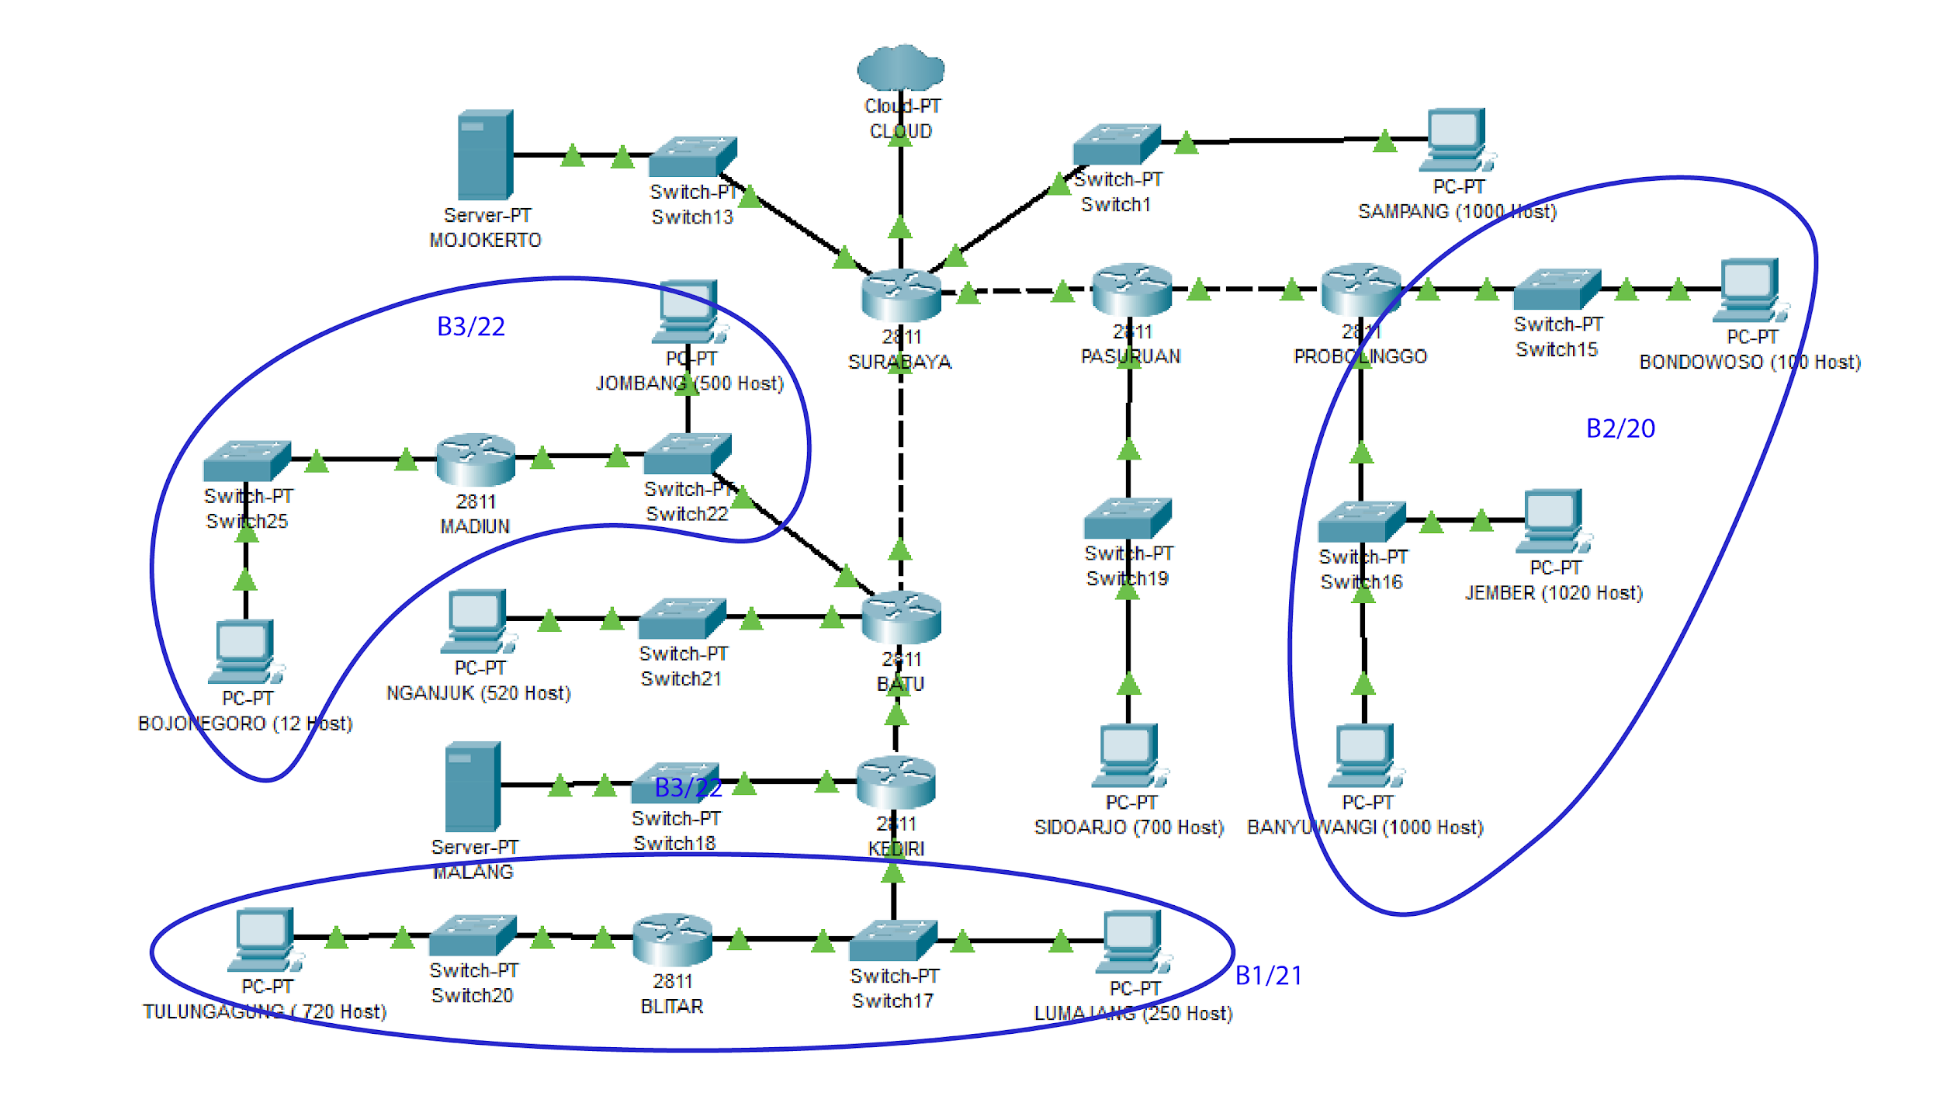

**Class C**

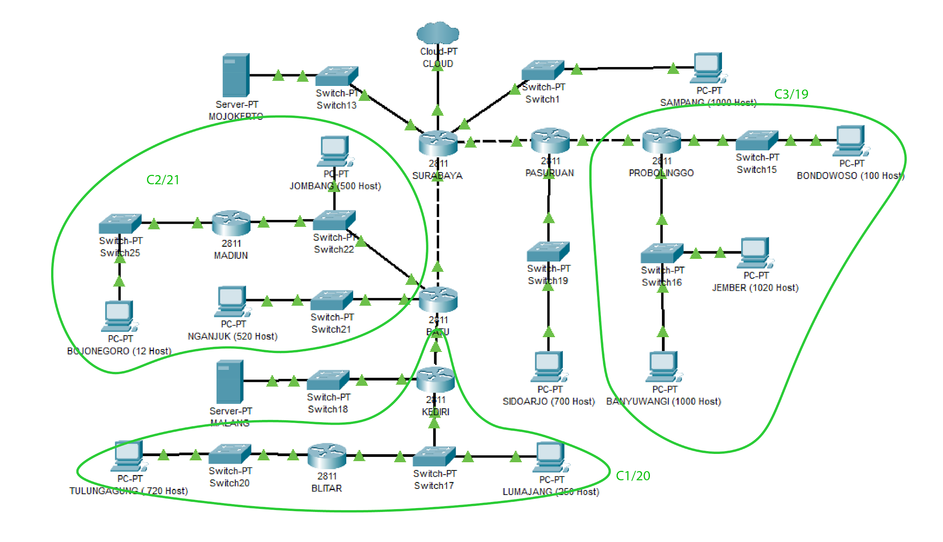

**Class D**

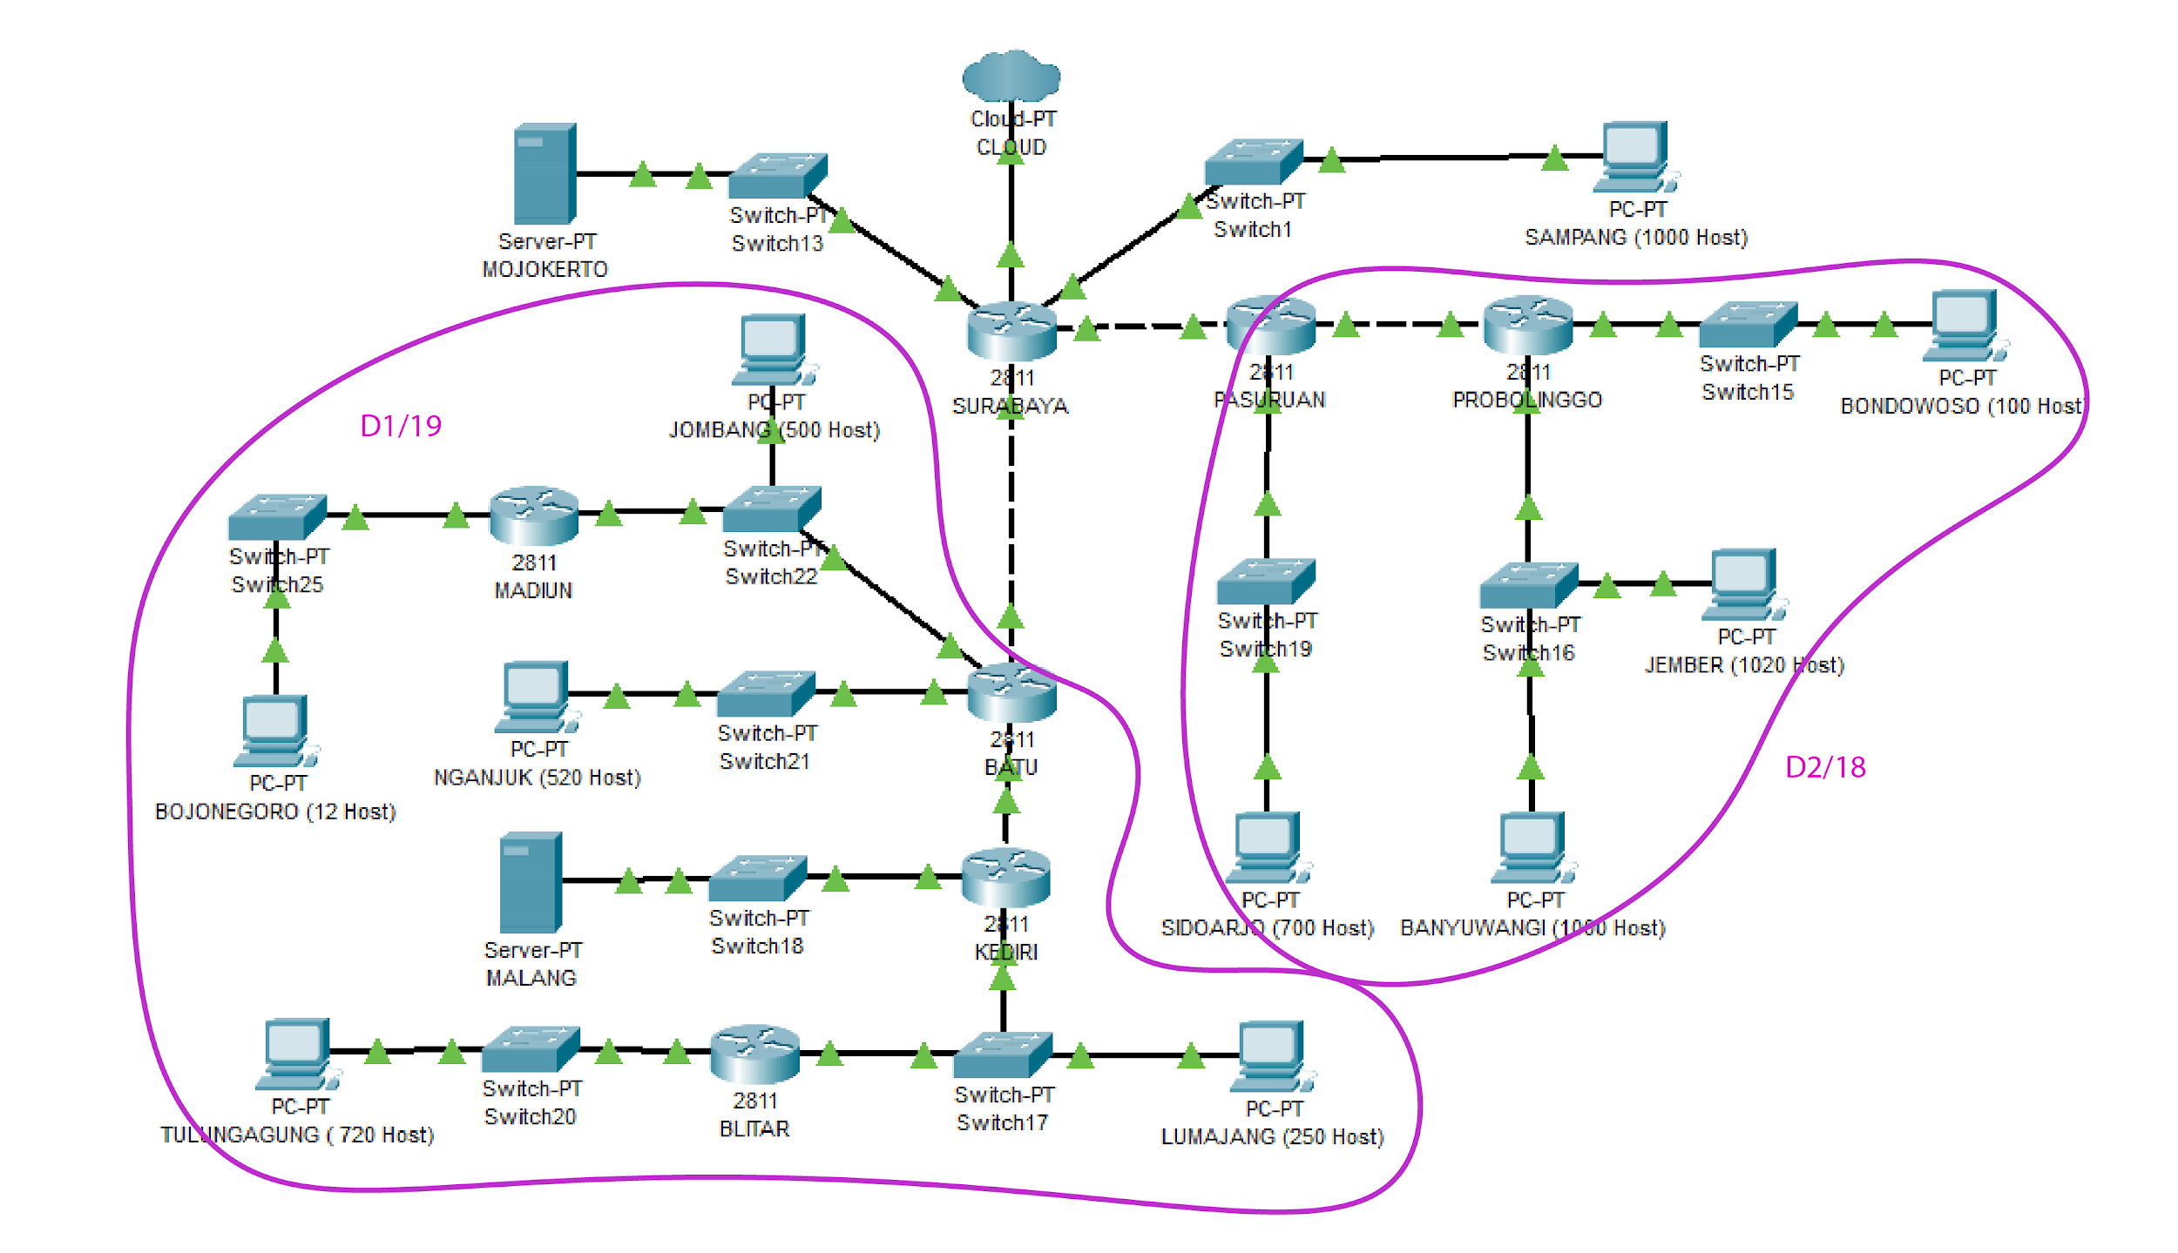

**Class E**

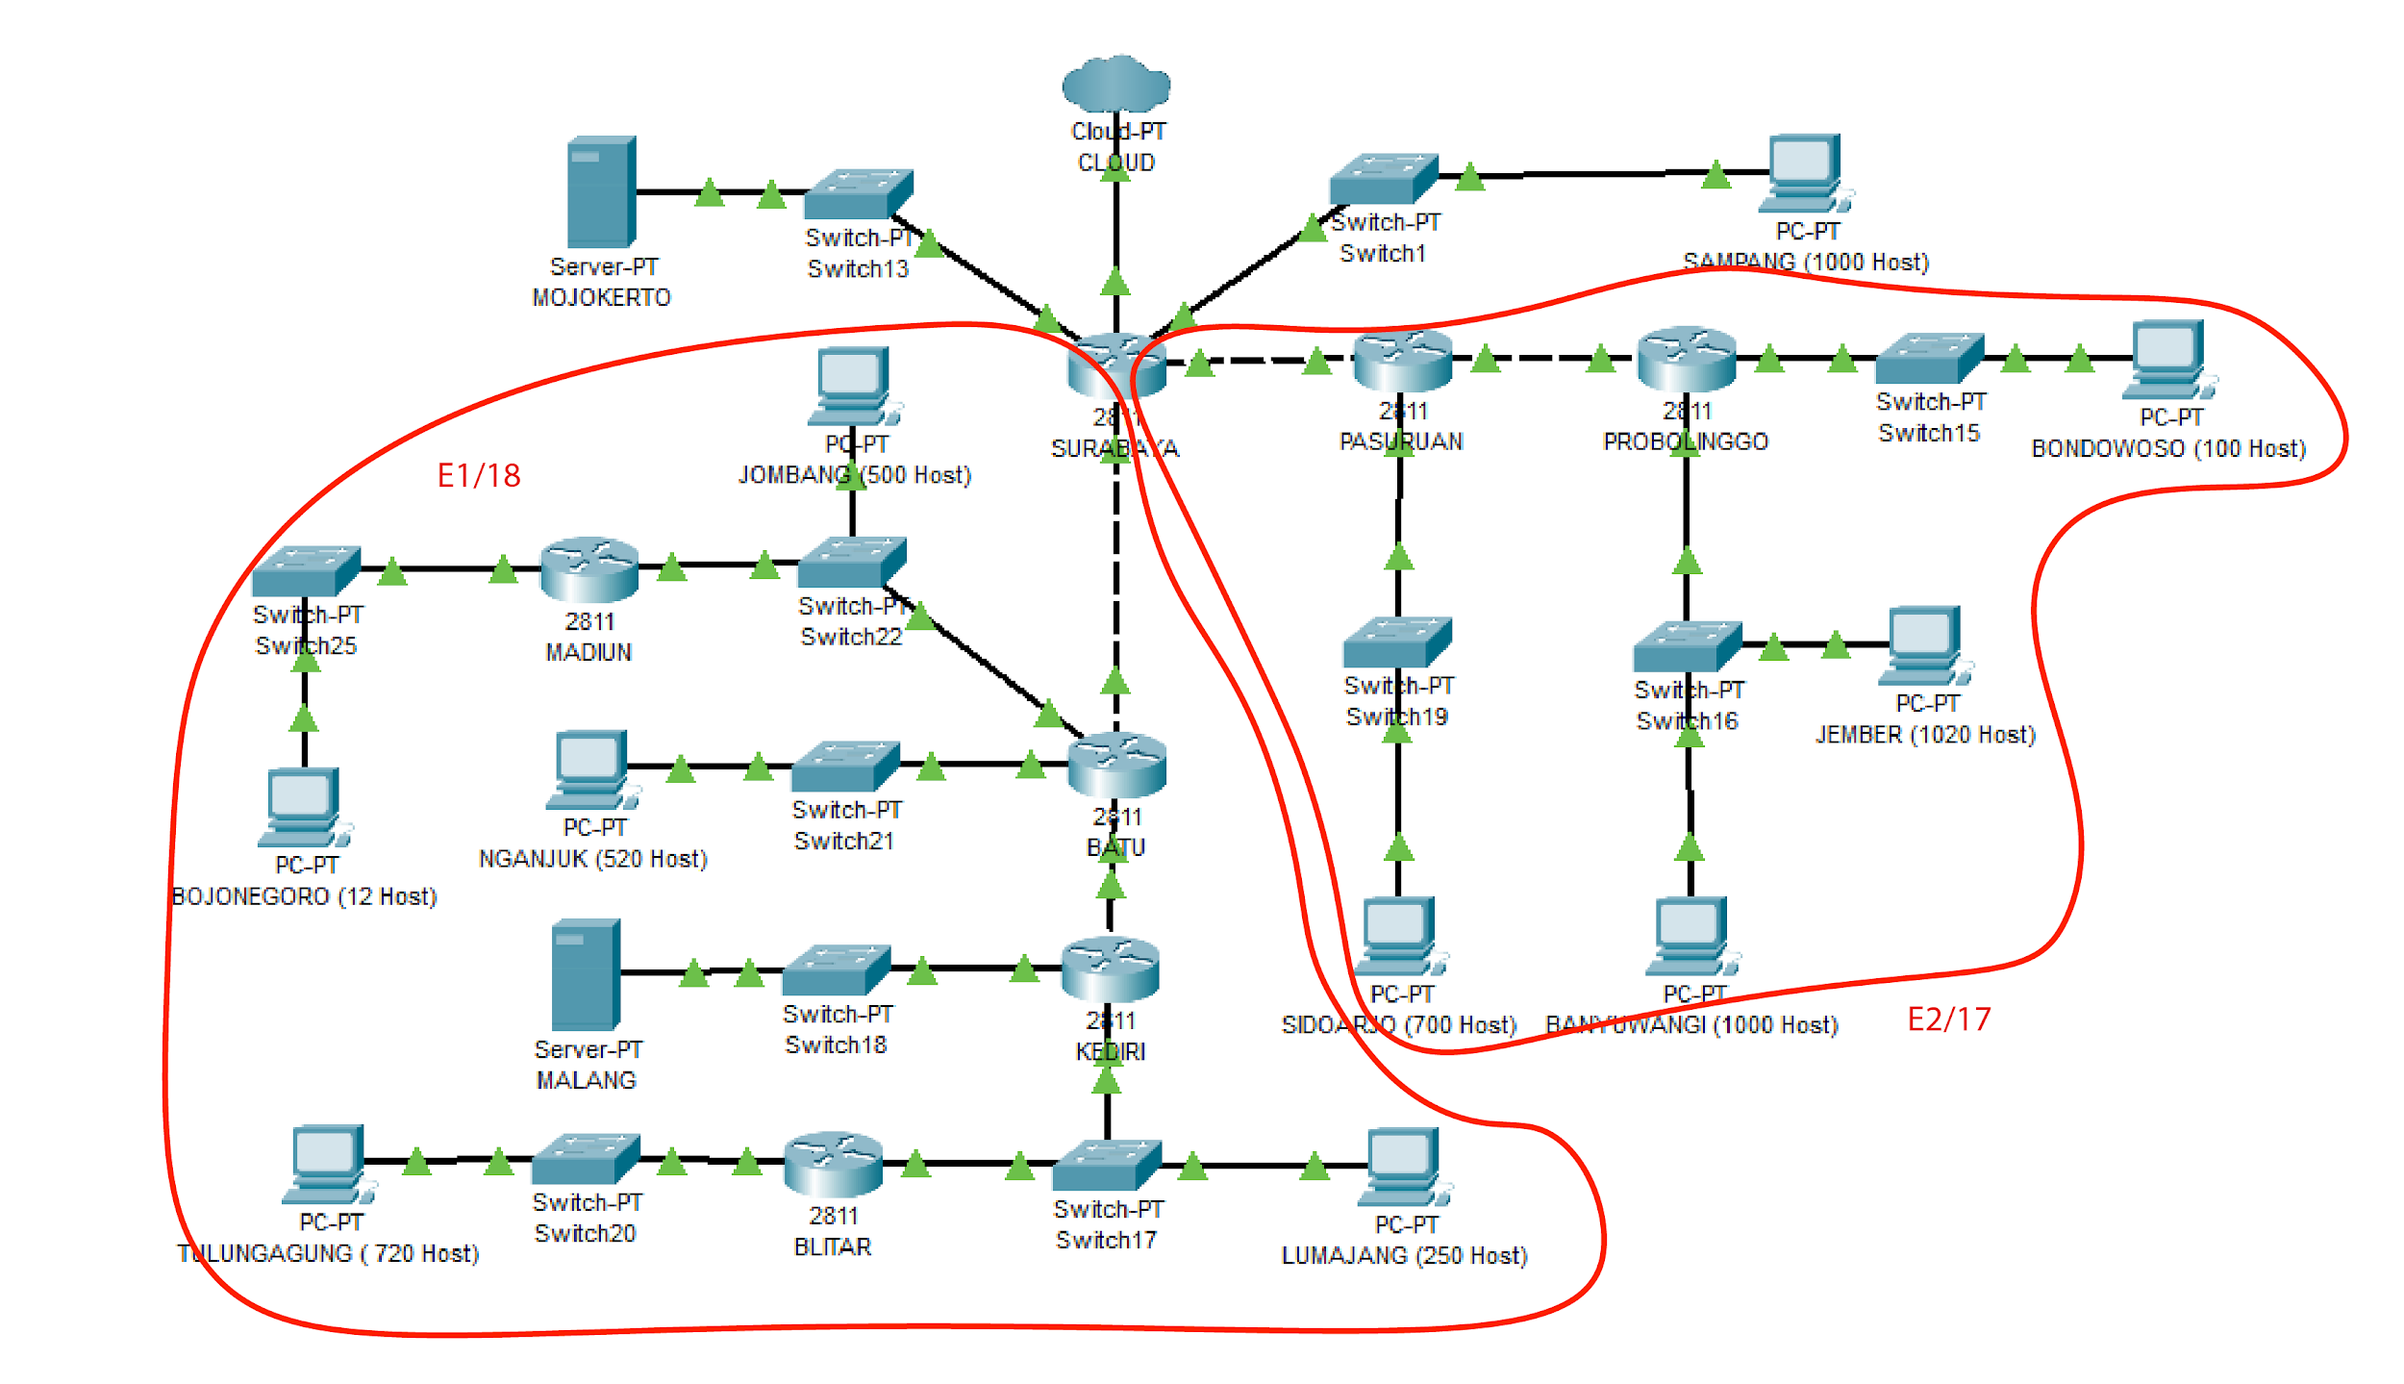

**Class F**

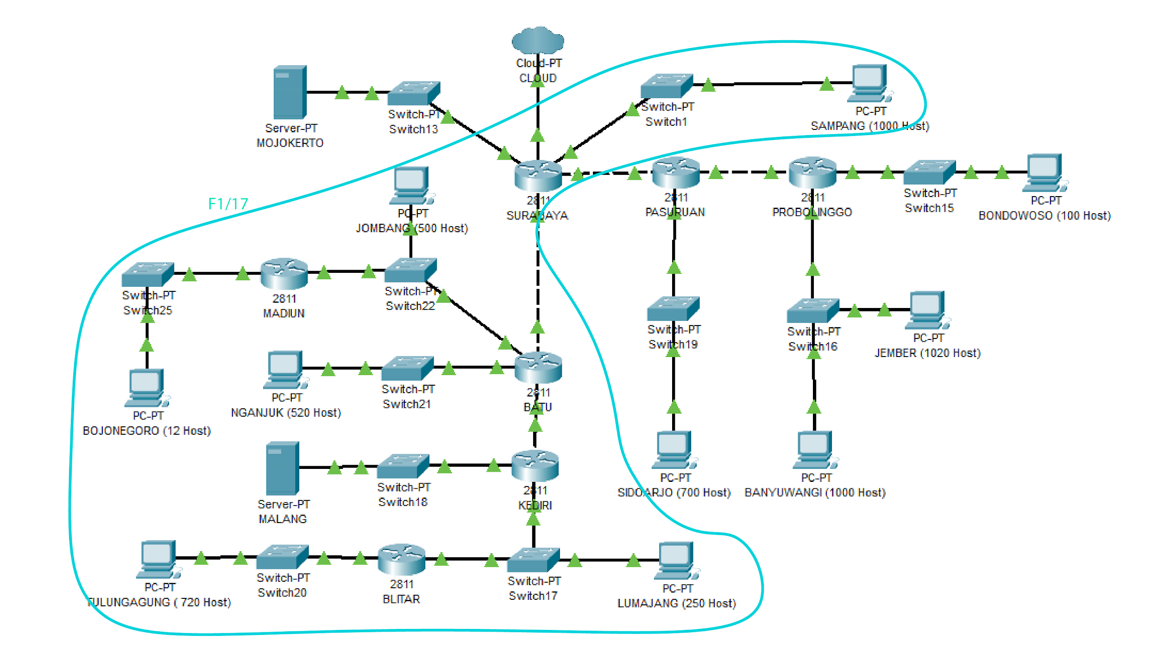

**Class G**

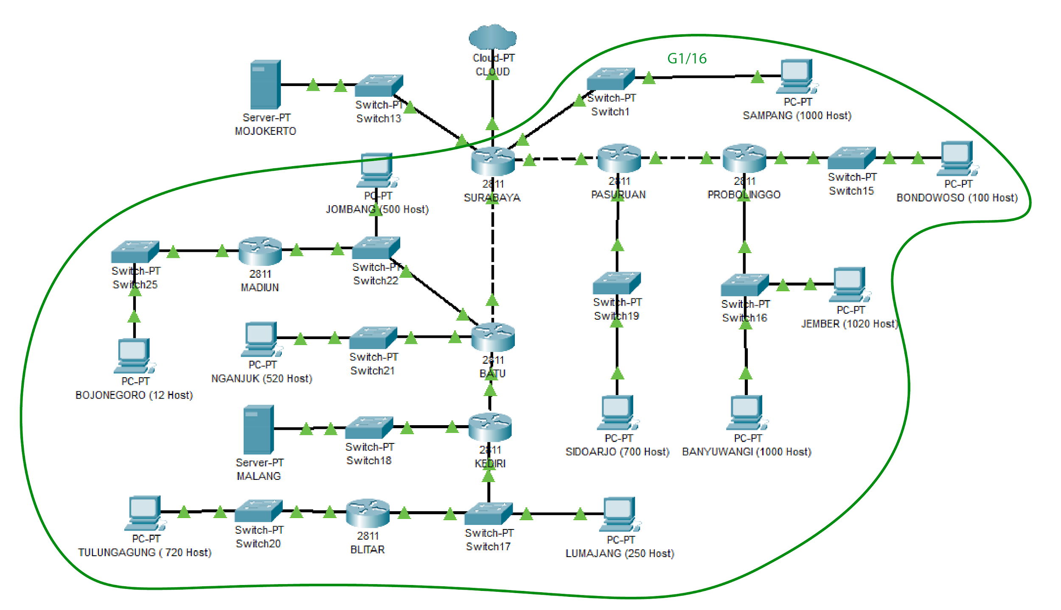

**Dari pembagian di atas didapatkan tree sebagai berikut**

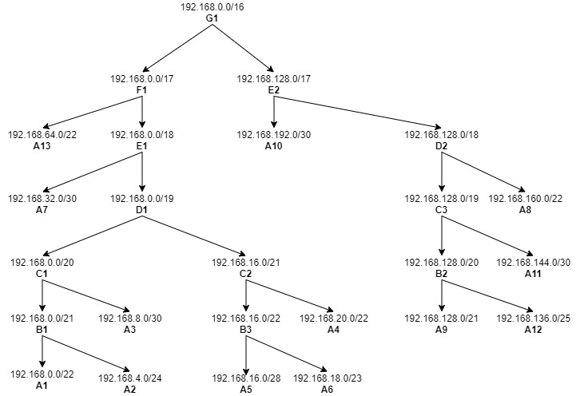

**Buat topologi.sh dengan mengikuti topologi yang telah diberikan**

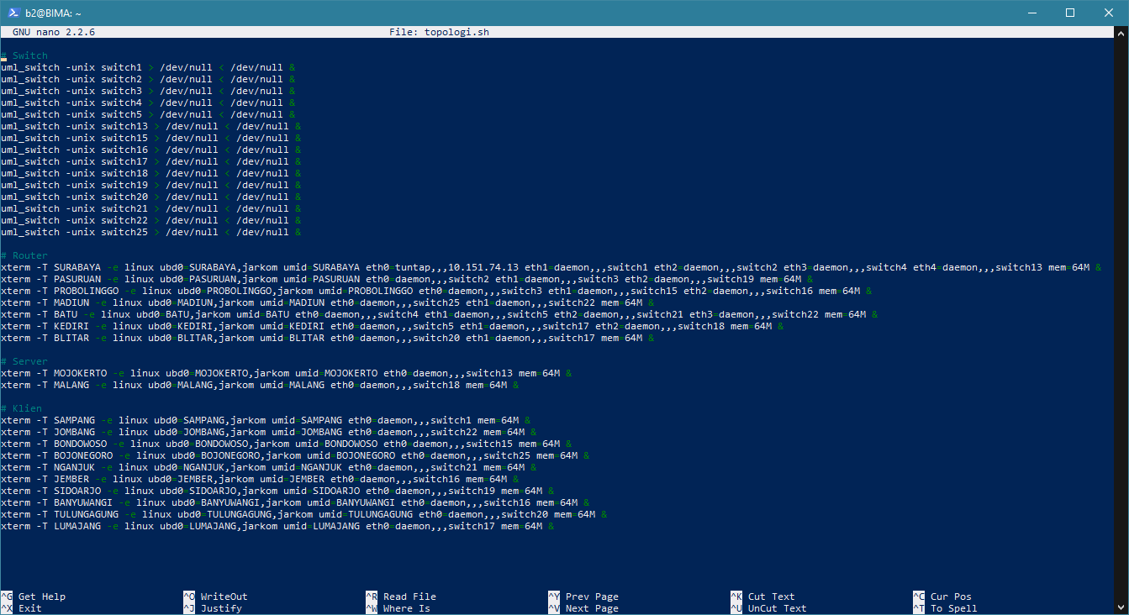

**Jalankan topologi.sh, kemudian ubah semua /etc/network/interfaces menjadi sebagai berikut**

1. Surabaya

#cloud

auto eth0

iface eth0 inet static

address 10.151.74.14

netmask 255.255.255.252

gateway 10.151.74.13

#sampang

auto eth1

iface eth1 inet static

address 192.168.64.1

netmask 255.255.252.0

#pasuruan

auto eth2

iface eth2 inet static

address 192.168.192.1

netmask 255.255.255.252

#batu

auto eth3

iface eth3 inet static

address 192.168.32.1

netmask 255.255.255.252

#mojokerto

auto eth4

iface eth4 inet static

address 10.151.83.25

netmask 255.255.255.252

1. pasuruan

auto lo

iface lo inet loopback

#surabaya

auto eth0

iface eth0 inet static

address 192.168.192.2

netmask 255.255.255.252

gateway 192.168.192.1

#probolinggo

auto eth1

iface eth1 inet static

address 192.168.144.1

netmask 255.255.255.252

#sidoarjo

auto eth2

iface eth2 inet static

address 192.168.160.1

netmask 255.255.252.0

1. probolinggo

auto lo

iface lo inet loopback

#pasuruan

auto eth0

iface eth0 inet static

address 192.168.144.2

netmask 255.255.255.252

gateway 192.168.144.1

#bondowoso

auto eth1

iface eth1 inet static

address 192.168.136.1

netmask 255.255.255.128

#jember&banyuwangi

auto eth2

iface eth2 inet static

address 192.168.128.1

netmask 255.255.248.0

1. bondowoso

auto lo

iface lo inet loopback

#probolinggo

auto eth0

iface eth0 inet static

address 192.168.136.2

netmask 255.255.255.128

gateway 192.168.136.1

1. jember

auto lo

iface lo inet loopback

#probolinggo

auto eth0

iface eth0 inet static

address 192.168.128.2

netmask 255.255.248.0

gateway 192.168.128.1

1. banyuwangi

auto lo

iface lo inet loopback

#probolinggo

auto eth0

iface eth0 inet static

address 192.168.128.3

netmask 255.255.248.0

gateway 192.168.128.1

1. sidoarjo

auto lo

iface lo inet loopback

#pasuruan

auto eth0

iface eth0 inet static

address 192.168.160.2

netmask 255.255.252.0

gateway 192.168.160.1

1. sampang

auto lo

iface lo inet loopback

#surabaya

auto eth0

iface eth0 inet static

address 192.168.64.2

netmask 255.255.252.0

gateway 192.168.64.1

1. batu

auto lo

iface lo inet loopback

#surabaya

auto eth0

iface eth0 inet static

address 192.168.32.2

netmask 255.255.255.252

gateway 192.168.32.1

#kediri

auto eth1

iface eth1 inet static

address 192.168.8.1

netmask 255.255.255.252

#nganjuk

auto eth2

iface eth2 inet static

address 192.168.20.1

netmask 255.255.252.0

#jombang

auto eth3

iface eth3 inet static

address 192.168.18.1

netmask 255.255.254.0

1. nganjuk

auto lo

iface lo inet loopback

#batu

auto eth0

iface eth0 inet static

address 192.168.20.2

netmask 255.255.252.0

gateway 192.168.20.1

1. jombang

auto lo

iface lo inet loopback

#batu

auto eth0

iface eth0 inet static

address 192.168.18.2

netmask 255.255.254.0

gateway 192.168.18.1

1. madiun

auto lo

iface lo inet loopback

#bojonegoro

auto eth0

iface eth0 inet static

address 192.168.16.1

netmask 255.255.255.240

#batu

auto eth1

iface eth1 inet static

address 192.168.18.3

netmask 255.255.254.0

gateway 192.168.18.1

1. kediri

auto lo

iface lo inet loopback

#batu

auto eth0

iface eth0 inet static

address 192.168.8.2

netmask 255.255.255.252

gateway 192.168.8.1

#lumajang

auto eth1

iface eth1 inet static

address 192.168.4.1

netmask 255.255.255.0

#malang

auto eth2

iface eth2 inet static

address 10.151.83.29

netmask 255.255.255.252

1. lumajang

auto lo

iface lo inet loopback

#kediri

auto eth0

iface eth0 inet static

address 192.168.4.2

netmask 255.255.255.0

gateway 192.168.4.1

1. blitar

auto lo

iface lo inet loopback

#tulungagung

auto eth0

iface eth0 inet static

address 192.168.0.1

netmask 255.255.252.0

#kediri

auto eth1

iface eth1 inet static

address 192.168.4.3

netmask 255.255.255.0

gateway 192.168.4.1

1. tulungagung

auto lo

iface lo inet loopback

#blitar

auto eth0

iface eth0 inet static

address 192.168.0.2

netmask 255.255.252.0

gateway 192.168.0.1

1. bojonegoro

auto lo

iface lo inet loopback

#madiun

auto eth0

iface eth0 inet static

address 192.168.16.2

netmask 255.255.255.240

gateway 192.168.16.1

1. mojokerto

#surabaya

auto eth0

iface eth0 inet static

address 10.151.83.26

netmask 255.255.255.252

gateway 10.151.83.25

1. malang

#kediri

auto eth0

iface eth0 inet static

address 10.151.83.30

netmask 255.255.255.252

gateway 10.151.83.29

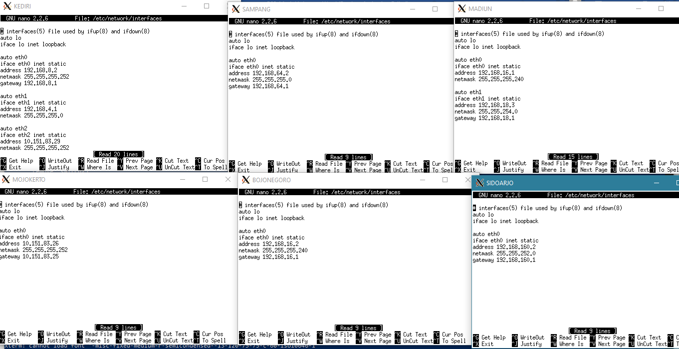

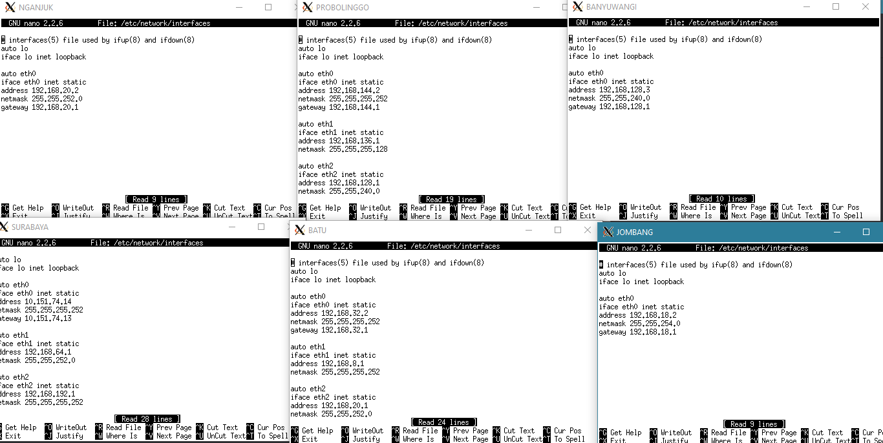

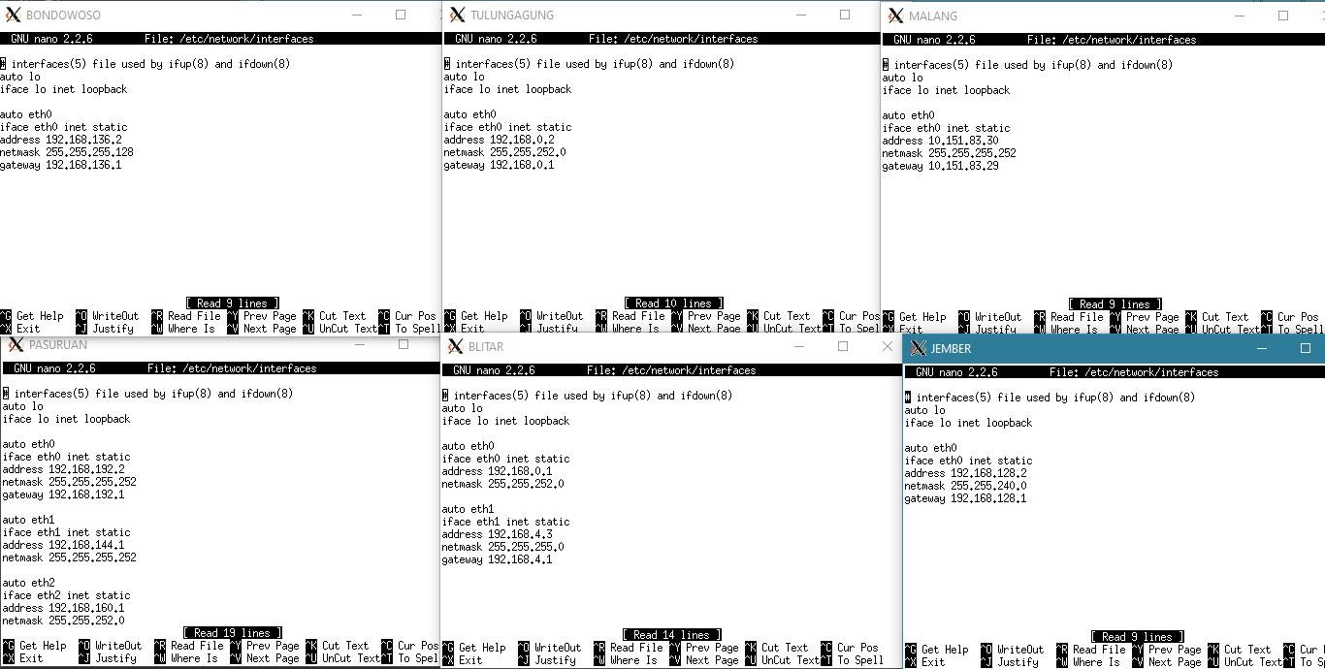

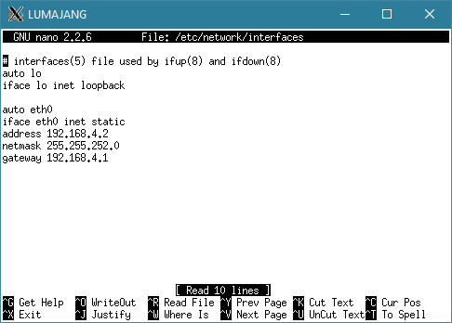

**Lakukan routing di Surabaya, Pasuruan, Batu, dan Kediri**

1. SURABAYA

#pasuruan

route add -net 192.168.128.0 netmask 255.255.192.0 gw 192.168.192.2

#batu

route add -net 192.168.0.0 netmask 255.255.224.0 gw 192.168.32.2

#malang

route add -net 10.151.83.28 netmask 255.255.255.252 gw 192.168.32.2

1. PASURUAN

#probilinggo

route add -net 192.168.128.0 netmask 255.255.240.0 gw 192.168.144.2

1. BATU

#kediri

route add -net 192.168.0.0 netmask 255.255.248.0 gw 192.168.8.2

#malang

route add -net 10.151.83.28 netmask 255.255.255.252 gw 192.168.8.2

#madiun

route add -net 192.168.16.0 netmask 255.255.252.0 gw 192.168.18.3

1. KEDIRI

#blitar

route add -net 192.168.0.0 netmask 255.255.248.0 gw 192.168.4.3

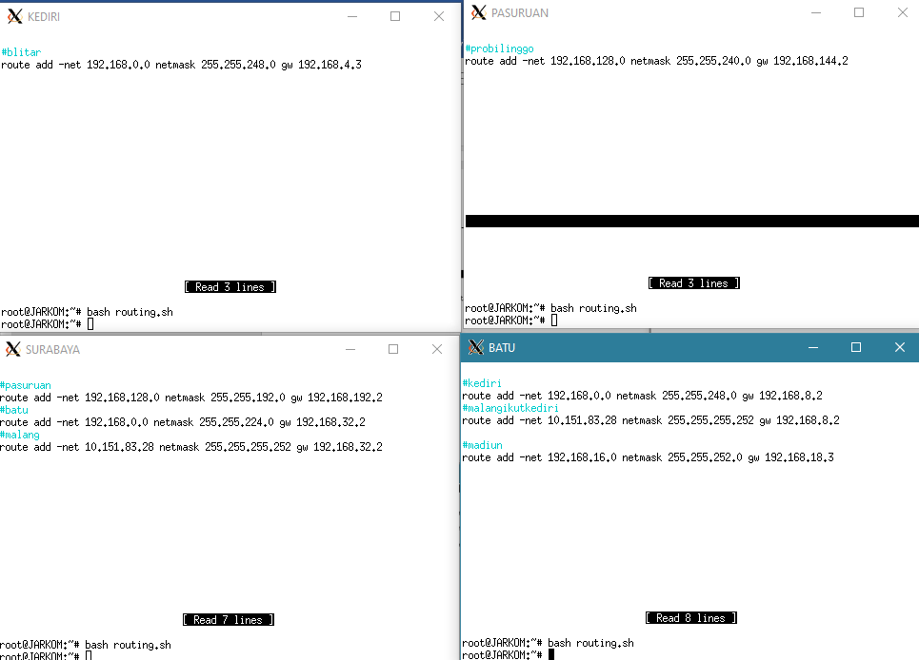

**Uncomment net.ipv4.ip_forward = 1 di /etc/sysctl.conf, kemudian jalankan sysctl -p (lakukan di semua router)**

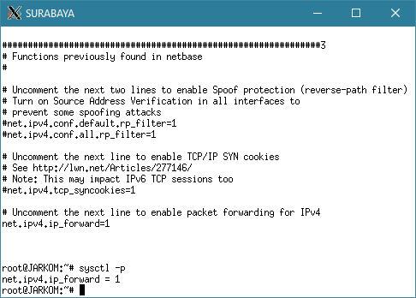

**Lakukan iptables di Surabaya**

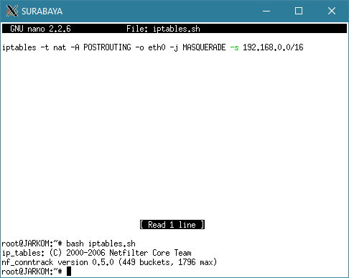

**Testing dengan melakukan ping its.ac.id**

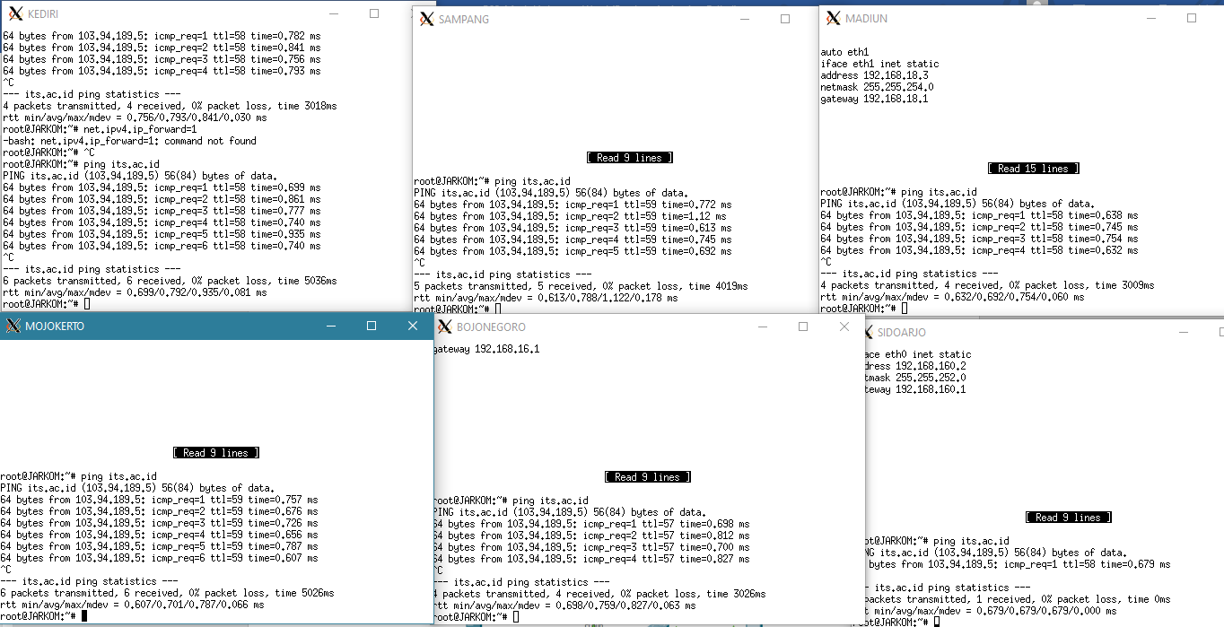

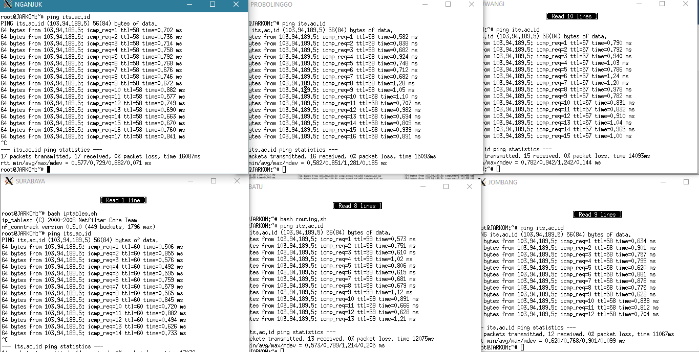

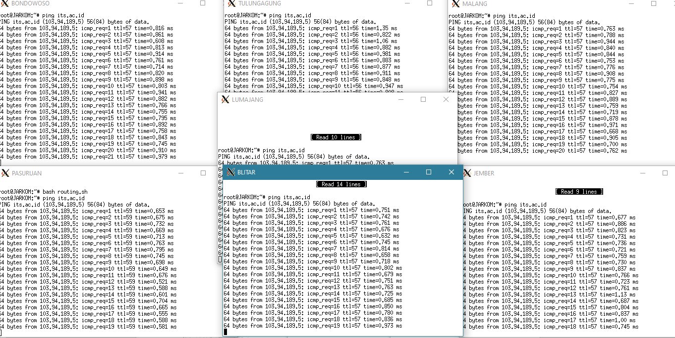

**VSLM**

**Topologi awal**

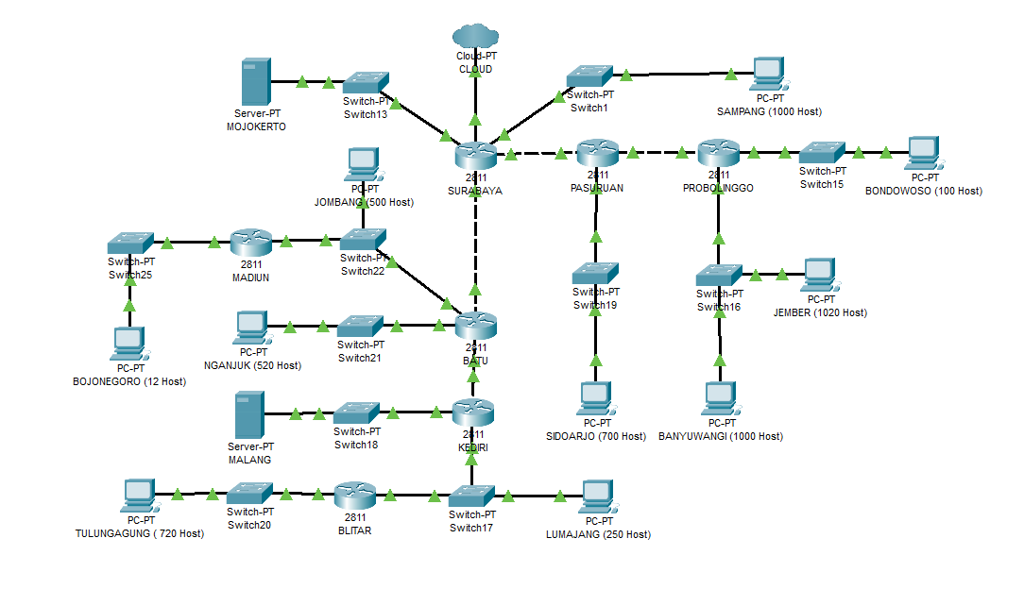**Dibagi tiap subnet**

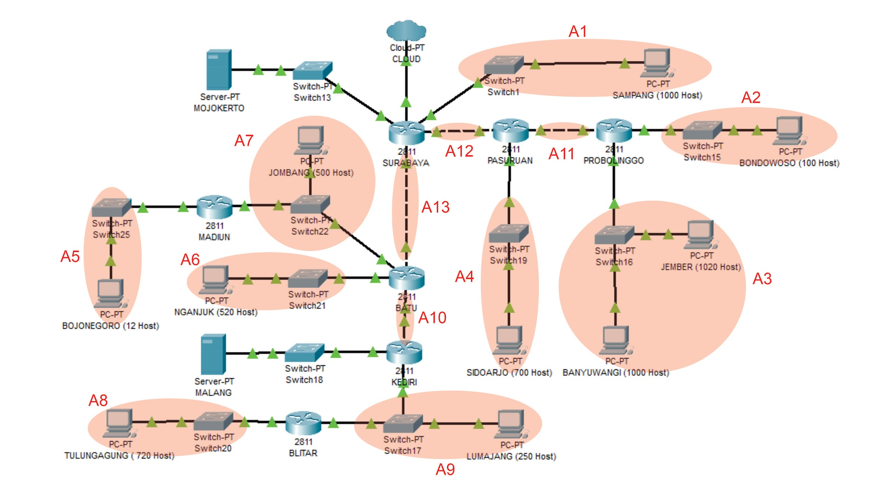

**Menghitung Total IP**

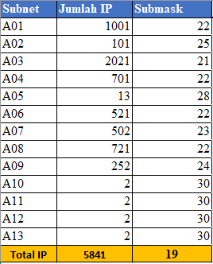

**VSLM Tree**

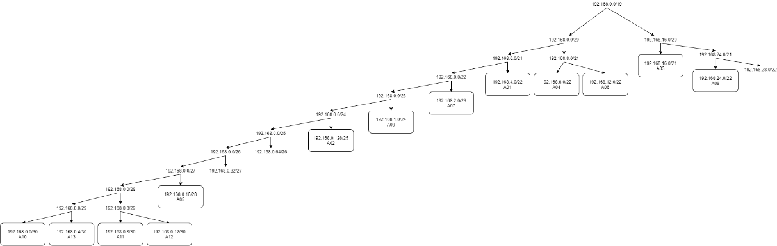

**Pembagian NID**

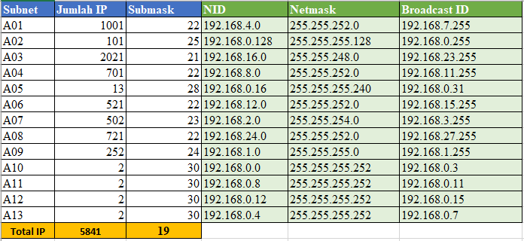

**Routing**

